Nicholas Skinner

CS 453

Spring 2019

**Project #6: ParaView Vector Visualization**

**Arrows: Colored by magnitude.**

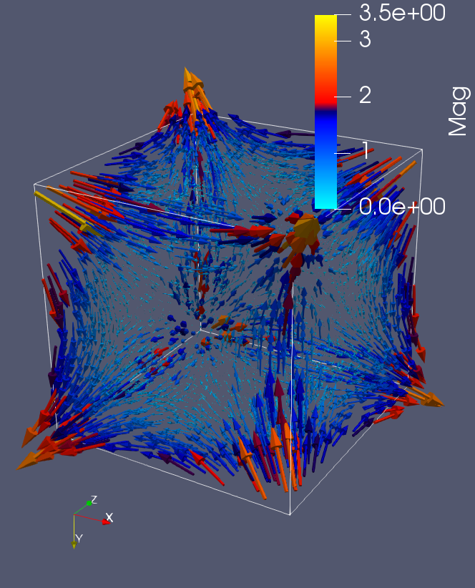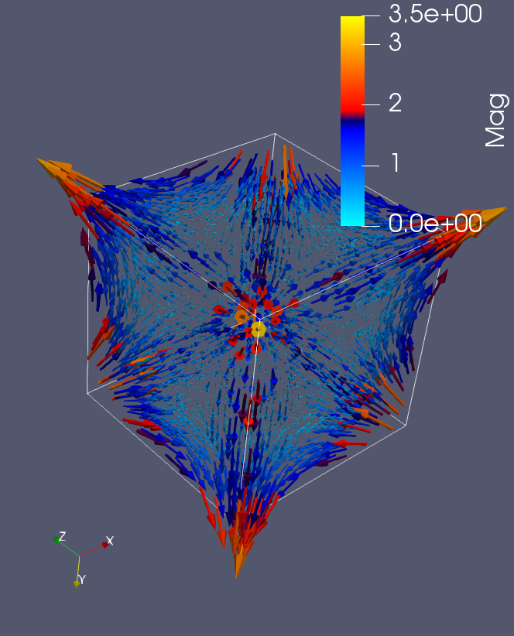

**Stream Ribbon and Tube: colored by Curl**

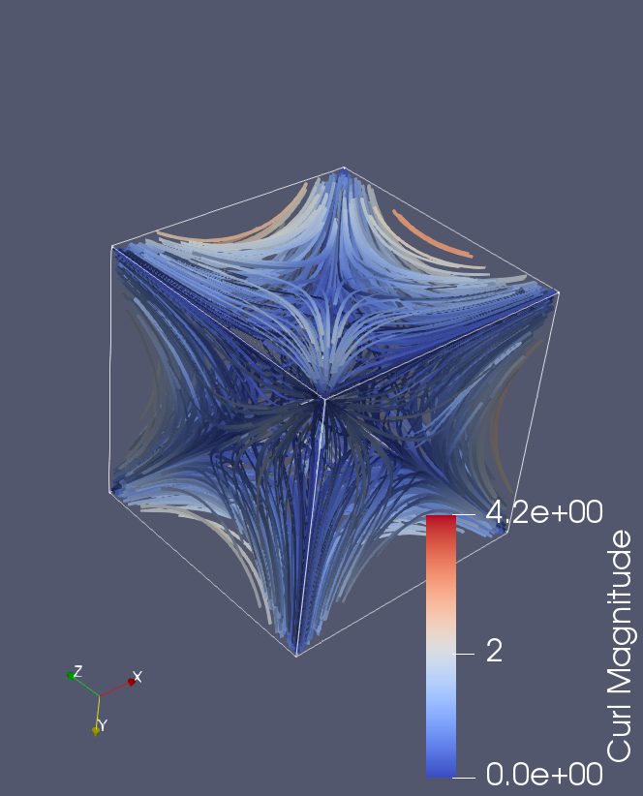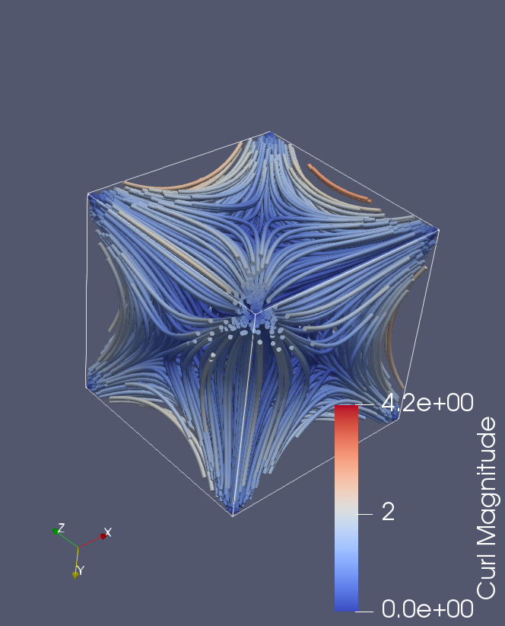

**Just for fun: Ribbons and tubes with magnitude coloring**

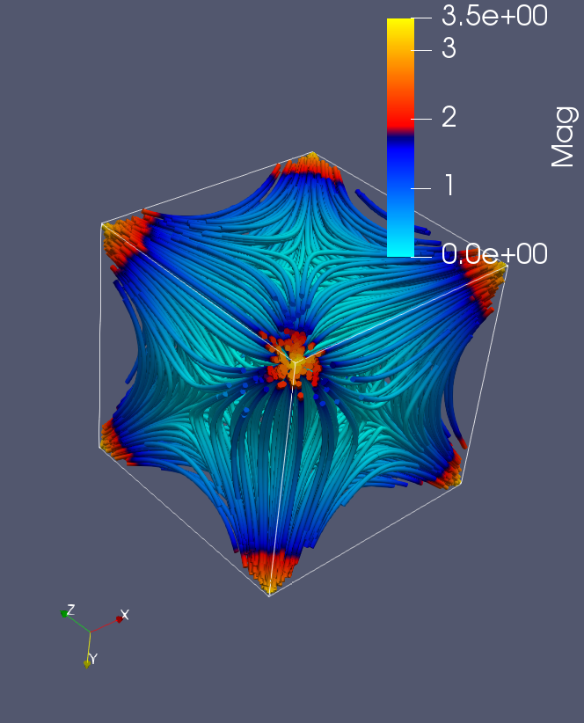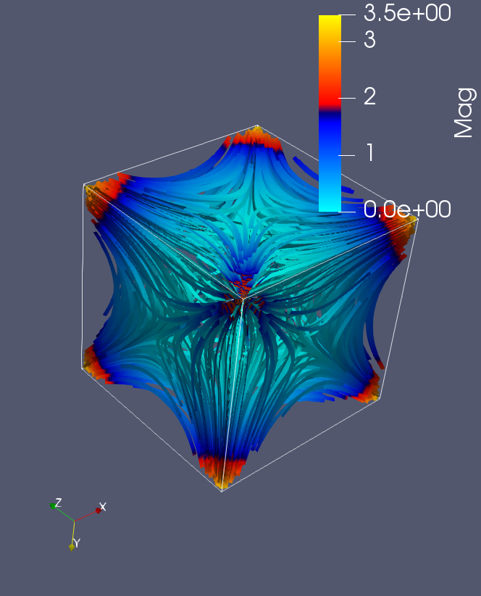

**Extra Credit: Left and right eye arrows:**

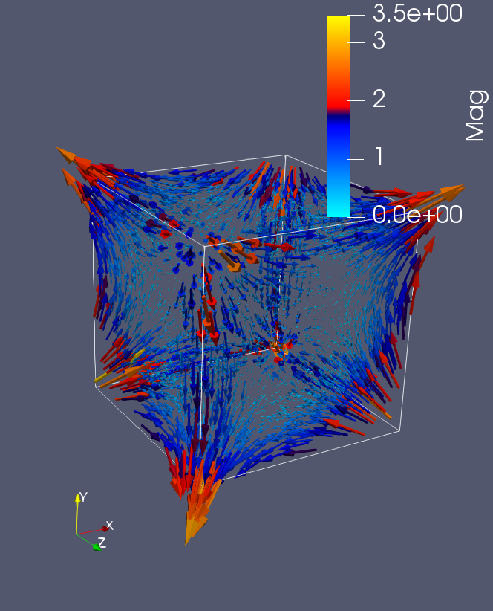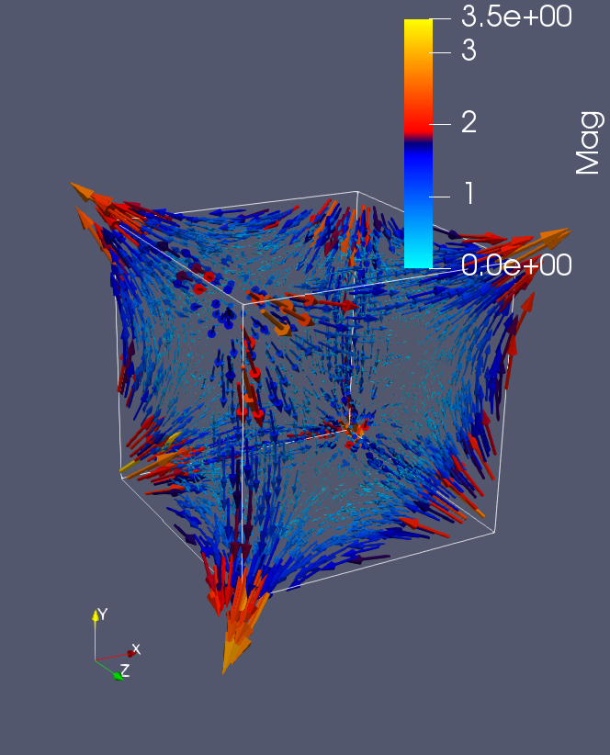

**Transfer Function:** I just used the base blue to red, it easily illustrates the differences between low and high, and is very easily differentiable. I do think I should modify it slightly though to incorporate more in between low and high readings.

**Video Link:** [**https://media.oregonstate.edu/media/0_dxn6kh3x**](https://media.oregonstate.edu/media/0_dxn6kh3x)